Primerus South Central Regional Meeting | May 15  2015
 |  | Fort Worth, TX

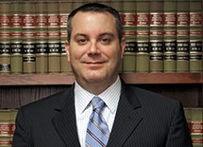
Ian Beliveaux
Donato, Minx, Brown & Pool, P.C.
Houston, TX
ibeliveaux@donatominxbrown.com
713.877.1112

Main Practice Area/s:
Insurance Defense, Subrogation
Ashley Belleau
Montgomery Barnett, L.L.P.
New Orleans, LA
abelleau@monbar.com
504.585.3200

Main Practice Area/s:
Admiralty/Maritime; Bankruptcy; Business Litigation; Construction; Energy, Natural Resources, and Oil and Gas Law; Fidelity & Surety; Professional Liability Defense; Insurance Coverage & Extra-Contractual Liability; and Mediation and Arbitration
Marc Brockhaus
Dunlap Codding
Oklahoma City, OK
mbrockhaus@dunlapcodding.com
405.607.8600

Main Practice Area/s:
Intellectual Property and IP Litigation

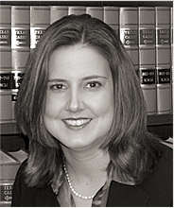
Whitney Cardwell
Moses, Palmer & Howell, L.L.P.
Fort Worth, TX
wcardwell@mph-law.com
817.255.9100

Main Practice Area/s:
Litigation, Oil & Gas, Business Transactions/Corporate, Banking, Real Estate and Family Law
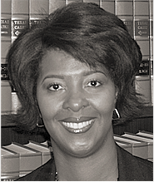
Tawanna Cesare
Moses, Palmer & Howell, L.L.P.
Fort Worth, TX
tcesare@mph-law.com
817.255.9100

Main Practice Area/s:
Litigation, Oil & Gas, Business Transactions/Corporate, Banking, Real Estate and Family Law
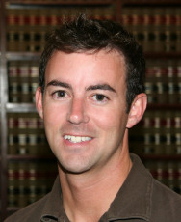
Brandon Cogburn
Atchley, Russell, Waldrop & Hlavinka, L.L.P.
Texarkana, TX
bcogburn@arwhlaw.com
903.792.8246

Main Practice Area/s:
Municipal Law, Toxic Torts Law, Environmental Law, Environmental Litigation Law, Litigation, Torts Law, Contracts Law

Jeremy Cook
Downs ♦ Stanford, P.C.
Dallas, TX
jcook@downsstanford.com
214.748.7900

Main Practice Area/s:
Personal Injury Defense, Worker’s Compensation, Appellate Law, Maritime Law, Insurance Coverage, Insurance Defense, Subrogation
Shannon Davis
James, Potts & Wulfers, Inc.
Tulsa, OK
sdavis@jpwlaw.com
918.584.0881

Main Practice Area/s:
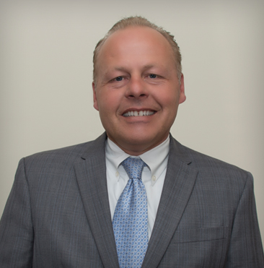
Real Estate Law, Business Law, Commercial Law, Civil Litigation Law, Complex Litigation Law, Appellate Practice Law, Business Litigation Law
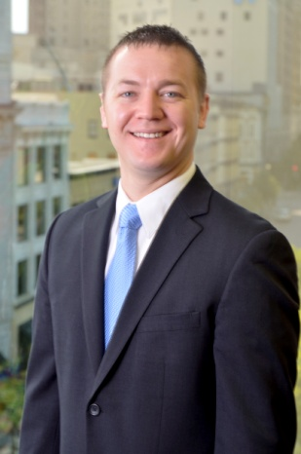
Chris Dawe
Primerus
Grand Rapids, MI
cdawe@primerus.com

Jay Downs
Downs ♦ Stanford, P.C.
Dallas, TX
jdowns@downsstanford.com
214.748.7900

Main Practice Area/s:
Personal Injury Defense, Worker's Compensation, Appellate Law, Maritime Law, Insurance Coverage, Insurance Defense,
Subrogation
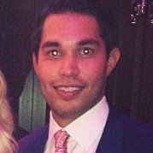
Zac Farrar
Moses, Palmer & Howell, L.L.P.
Fort Worth, TX
zfarrar@mph-law.com
817.255.9100

Main Practice Area/s:
Litigation, Oil & Gas, Business Transactions/Corporate, Banking, Real Estate and Family Law
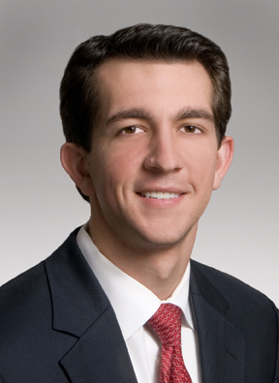
Jeff Finley
Thornton, Biechlin, Segrato, Reynolds & Guerra, L.C.
San Antonio, TX
jfinley@thorntonfirm.com
210.342.5555

Main Practice Area/s:
Insurance Defense: Personal/Commercial Auto Claims, Professional Liability, Medical Malpractice

Jon Godoy
Downs ♦ Stanford, P.C.
Dallas, TX
jgodoy@downsstanford.com
214.748.7900

Main Practice Area/s:
Personal Injury Defense, Worker’s Compensation, Appellate Law, Maritime Law, Insurance Coverage, Insurance Defense,
Subrogation
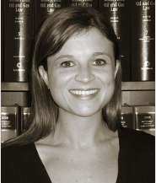
Alyson Halpern
Moses, Palmer & Howell, L.L.P.
Fort Worth, TX
ahalpern@mph-law.com
817.255.9100

Main Practice Area/s:
Litigation, Oil & Gas, Business Transactions/Corporate, Banking, Real Estate and Family Law
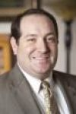
Ashton Handley
The Handley Law Center
El Reno, OK
ash@handleylaw.com
405.295.1924

Main Practice Area/s:
Personal Injury, Asbestos, Family Law, Criminal Law

Alex Handley
The Handley Law Center
El Reno, OK
alex@handleylaw.com
405.295.1924

Main Practice Area/s:
Personal Injury, Asbestos, Family Law, Criminal Law
Timothy Howell
Moses, Palmer & Howell, L.L.P.
Fort Worth, TX
thowell@mph-law.com
817.255.9100

Main Practice Area/s:
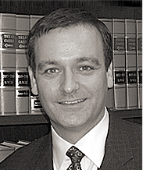
Litigation, Oil & Gas, Business Transactions/Corporate, Banking, Real Estate and Family Law
Janice Menzies
Downs ♦ Stanford, P.C.
Dallas, TX
jmenzies@downsstanford.com
214.748.7900

Main Practice Area/s:
Personal Injury Defense, Worker’s Compensation, Appellate Law, Maritime Law, Insurance Coverage, Insurance Defense,
Subrogation

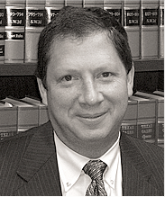
Shayne Moses
Moses, Palmer & Howell, L.L.P.
Fort Worth, TX
smoses@mph-law.com
817.255.9100

Main Practice Area/s:
Litigation, Oil & Gas, Business Transactions/Corporate, Banking, Real Estate and Family Law
T.B. “Nick” Nicholas
Downs ♦ Stanford, P.C.
Dallas, TX
nnicholas@downsstanford.com
214.748.7900

Main Practice Area/s:
Personal Injury Defense, Worker’s Compensation, Appellate Law, Maritime Law, Insurance Coverage, Insurance Defense,
Subrogation

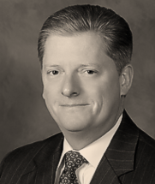
David Palmer
Moses, Palmer & Howell, L.L.P.
Fort Worth, TX
dpalmer@mph-law.com
817.255.9100

Main Practice Area/s:
Litigation, Oil & Gas, Business Transactions/Corporate, Banking, Real Estate and Family Law
Michael Prather
Donato, Minx, Brown & Pool, P.C.
Houston, TX
mprather@donatominxbrown.com
713.877.1112

Main Practice Area/s:
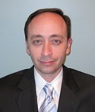
Insurance Defense, Personal Injury/Wrongful Death, Subrogation, Insurance Claims Resolution, Fire/Explosion, Trucking/Transportation, Medial/Professional Liability Litigation,
Premises Liability, Products Liability, General
Civil Litigation, Maritime
Laura Schmidt
Downs ♦ Stanford, P.C.
Dallas, TX
lschmidt@downsstanford.com
214.748.7900

Main Practice Area/s:
Personal Injury Defense, Worker’s Compensation, Appellate Law, Maritime Law, Insurance Coverage, Insurance Defense,
Subrogation

Wendy Schrock
Downs ♦ Stanford, P.C.
Dallas, TX
wschrock@downsstanford.com
214.748.7900

Main Practice Area/s:
Personal Injury Defense, Worker’s Compensation, Appellate Law, Maritime Law, Insurance Coverage, Insurance Defense,
Subrogation

